**BOTSWANA MANDATORY PLAN**

**Delivery system**

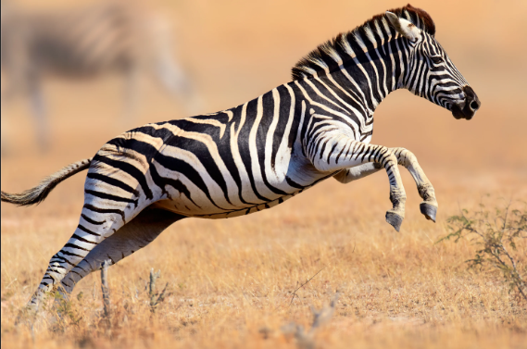

After a good time analyzing Botswana and see what it might need and what it already have ,we have come to note that people are facing problems on transferring goods from one city to another and for that we have sit down and discuss about how to overcome this problem.

**Focusing on delivery system**

After a powerful research we found out that we have Botswana post tracking system and it only covers things that are bought online from sites like amazon , wishy and ebay. This system is the only system registered to transfer products from other counties to Botswana.

**Current problems:**

1. Delay goods on warehouse(goods are only allowed to stay in warehouse for more than 3 days).
2. Tight schedule for people to collect goods due to pandemic break out.
3. Some people leave very far from the main warehouses.

**The solution to the problems mentioned above:**

1. We then decided to do a local and global delivery system that will be helpful to the growth of Botswana’s economy by 70% because of the following facts.
2. People will no longer need to visit warehouse or to send someone with their goods to another city because we are there to help with this system.
3. The system will increase the rate of employment by approximately 60% since we will need all sort of people with their abilities to take party .
4. We will seek high security from the police for safe delivery and crime scenes during the long run of the system.
5. Goods will be in safe hands since the company will be back up with insurance company and the government.

So the country is capable to take on several number of projects and on the big 10 projects the one which we can take using fast track method is home delivery system.

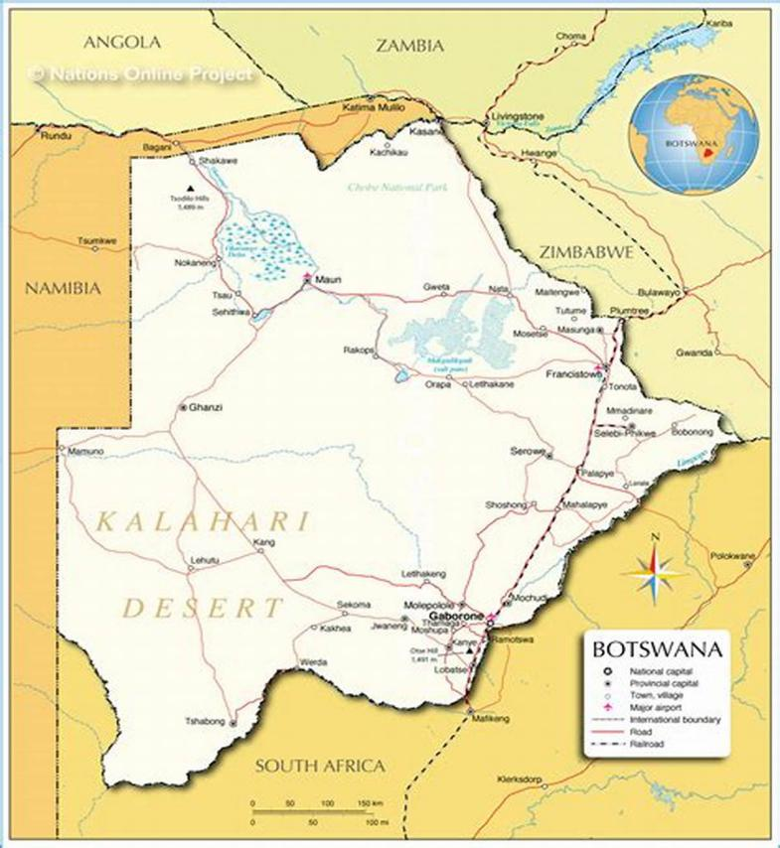

For start we can use the capital city and we then expand to other cities with the idea to put office’s in every city to make it easier for local people to send goods from one city to another and to also to send goods around the same city.

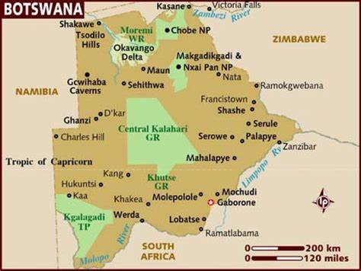

The capital city of Botswana is designed like this , that means we can use the regime formation to counter the plan for home delivery.

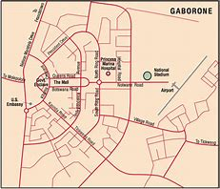

Using the color co-ordinated map of the Capital city we can see that we can put our office’s in the center of the city and our warehouse closer to airport in the range (1-7 km) since the plan will also work for international goods delivery.

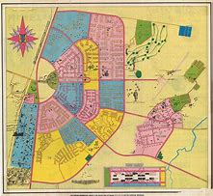

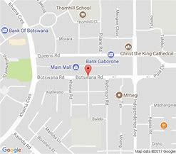

Requirements:

* For this project to start running we need offices in almost every city close to Gaborone then we expand according to the trust which we will gain from the people after a certain amount of time(approximately 3 months),
* While expanding out, we also increase the number of offices in many local areas so that people in those areas will be able to buy either online then send their goods with us.

**Basic Requirements for the company to start running:**

1. **license from the government, authorization papers,**

***Sample:***

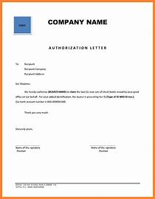

1. **We need a website to track our goods**



1. **We need vehicles to deliver the goods:**

They are several kinds of vehicles required but the main ones are the following:

1. **TRUCKS**

We need trucks for long range deliveries and with the hope we have the projects will be powerful in a period of 6 months.

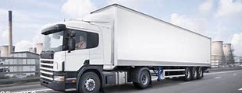

1. **VANS**

Sometimes we will have small packages for long ranges and we need vans to deliver those goods:

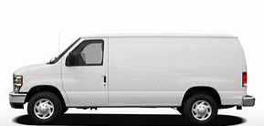

1. **SMALL FUEL SAVER CARS**

For local delivery we can use small cars like vits to deliver with the help of bikers which will be delivering door to door:

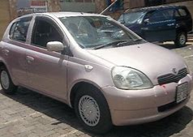

1. **BIKES**

We also need bikers for fast and reliable delivery in the local cities.

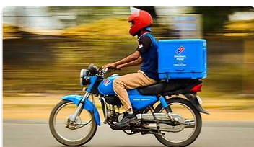

**Delivery Procedure**

* In the office the goods will be checked for drugs and other dangerous products which are not allowed
* We need cameras in every office for security.
* Tracking system for our vehicles.
* Qualified and talented people to work in different fields on the long run of the system.

**High Speed Priority**

*Question and answer*

*Question 0*

**How long will it take to implement the system?**

* If the government permits it to be developed the system will start running in less than 2 months.

*Question 1*

**What can we do to increase the power of our system?**

* We can upgrade our website to support online buying.
* it will be connected to the delivery system.

*Question 2*

**What can we do to increase the power of our system?**

* We can go for international delivery system from countries like China and America.

*Question 3*

**Will this be helpful to our local people?**

* Local companies and people will be able to buy products from other countries through online and their goods are delivered door to door with us.

*Question 4*

**Will people accept this system?**

* Yes, people will accept the system because it will be connected to the government and we will use trusted broadcast to advertise it ( to let people know ).

**35 CITIES TO BE COVERED FIRST**

We need to make sure that the system will cover the whole country in short time but we will start with the first 35 cities below:

1. Gaborone
2. Kanye
3. Palapye
4. Ghanzi
5. Francistown
6. Molepole0-
7. Maun
8. Hukuntsi
9. Letlhakane

-----------

-----------

-----------

1. Selibe Phikwe

* **Botwana have about 82 Cities , The system will cover all of them during the upgrade:**

[Gaborone](https://simple.wikipedia.org/wiki/Gaborone" \o "Gaborone),[Francistown](https://simple.wikipedia.org/wiki/Francistown" \o "Francistown),[Molepolole](https://simple.wikipedia.org/w/index.php?title=Molepolole&action=edit&redlink=1" \o "Molepolole (not yet started)),[Serowe](https://simple.wikipedia.org/w/index.php?title=Serowe&action=edit&redlink=1" \o "Serowe (not yet started)),[Selibe Phikwe](https://simple.wikipedia.org/w/index.php?title=Selebi-Phikwe&action=edit&redlink=1" \o "Selebi-Phikwe (not yet started)),[Maun](https://simple.wikipedia.org/w/index.php?title=Maun&action=edit&redlink=1" \o "Maun (not yet started)),[Kanye](https://simple.wikipedia.org/wiki/Kanye,_Botswana" \o "Kanye, Botswana), [Mahalapye](https://simple.wikipedia.org/w/index.php?title=Mahalapye&action=edit&redlink=1" \o "Mahalapye (not yet started)),[Mogoditshane](https://simple.wikipedia.org/w/index.php?title=Mogoditshane&action=edit&redlink=1" \o "Mogoditshane (not yet started)),[Mochudi](https://simple.wikipedia.org/w/index.php?title=Mochudi&action=edit&redlink=1" \o "Mochudi (not yet started)),[Lobatse](https://simple.wikipedia.org/w/index.php?title=Lobatse&action=edit&redlink=1" \o "Lobatse (not yet started)), [Palapye](https://simple.wikipedia.org/w/index.php?title=Palapye&action=edit&redlink=1" \o "Palapye (not yet started)),[Ramotswa](https://simple.wikipedia.org/w/index.php?title=Ramotswa&action=edit&redlink=1" \o "Ramotswa (not yet started)), [Moshupa](https://simple.wikipedia.org/w/index.php?title=Moshupa&action=edit&redlink=1" \o "Moshupa (not yet started)),[Tlokweng](https://simple.wikipedia.org/w/index.php?title=Tlokweng&action=edit&redlink=1" \o "Tlokweng (not yet started)), [Bobonong](https://simple.wikipedia.org/w/index.php?title=Bobonong&action=edit&redlink=1" \o "Bobonong (not yet started)),[Thamaga](https://simple.wikipedia.org/w/index.php?title=Thamaga&action=edit&redlink=1" \o "Thamaga (not yet started)),[Letlhakane](https://simple.wikipedia.org/w/index.php?title=Letlhakane&action=edit&redlink=1" \o "Letlhakane (not yet started)), [Tonota](https://simple.wikipedia.org/w/index.php?title=Tonota&action=edit&redlink=1" \o "Tonota (not yet started)),[Mmadinare](https://simple.wikipedia.org/w/index.php?title=Mmadinare&action=edit&redlink=1" \o "Mmadinare (not yet started)),[Jwaneng](https://simple.wikipedia.org/w/index.php?title=Jwaneng&action=edit&redlink=1" \o "Jwaneng (not yet started)), [Tutume](https://simple.wikipedia.org/w/index.php?title=Tutume&action=edit&redlink=1" \o "Tutume (not yet started)), [Gabane](https://simple.wikipedia.org/w/index.php?title=Gabane&action=edit&redlink=1" \o "Gabane (not yet started)),[Shoshong](https://simple.wikipedia.org/w/index.php?title=Shoshong&action=edit&redlink=1" \o "Shoshong (not yet started)), [Ghanzi](https://simple.wikipedia.org/w/index.php?title=Ghanzi&action=edit&redlink=1" \o "Ghanzi (not yet started)),[Letlhakeng](https://simple.wikipedia.org/w/index.php?title=Letlhakeng&action=edit&redlink=1" \o "Letlhakeng (not yet started)),[Orapa](https://simple.wikipedia.org/w/index.php?title=Orapa&action=edit&redlink=1" \o "Orapa (not yet started)), [Kopong](https://simple.wikipedia.org/w/index.php?title=Kopong&action=edit&redlink=1" \o "Kopong (not yet started)),[Mmopane](https://simple.wikipedia.org/w/index.php?title=Mmopane&action=edit&redlink=1" \o "Mmopane (not yet started)),[Kasane](https://simple.wikipedia.org/w/index.php?title=Kasane&action=edit&redlink=1" \o "Kasane (not yet started)), [Shakawe](https://simple.wikipedia.org/w/index.php?title=Shakawe&action=edit&redlink=1" \o "Shakawe (not yet started)),[Lentsweletau](https://simple.wikipedia.org/w/index.php?title=Lentsweletau&action=edit&redlink=1" \o "Lentsweletau (not yet started)),[Molapowabojang](https://simple.wikipedia.org/w/index.php?title=Molapowabojang&action=edit&redlink=1" \o "Molapowabojang (not yet started)), [Gumare](https://simple.wikipedia.org/w/index.php?title=Gumare&action=edit&redlink=1" \o "Gumare (not yet started)),[Tshabong](https://simple.wikipedia.org/w/index.php?title=Tshabong&action=edit&redlink=1" \o "Tshabong (not yet started)),[Lerala](https://simple.wikipedia.org/w/index.php?title=Lerala&action=edit&redlink=1" \o "Lerala (not yet started)), [Mmathethe](https://simple.wikipedia.org/w/index.php?title=Mmathethe&action=edit&redlink=1" \o "Mmathethe (not yet started)), [Gweta](https://simple.wikipedia.org/w/index.php?title=Gweta&action=edit&redlink=1" \o "Gweta (not yet started)), [Mathangwane](https://simple.wikipedia.org/w/index.php?title=Mathangwane&action=edit&redlink=1" \o "Mathangwane (not yet started)),[Mmankgodi](https://simple.wikipedia.org/w/index.php?title=Mmankgodi&action=edit&redlink=1" \o "Mmankgodi (not yet started)),[Maitengwe](https://simple.wikipedia.org/w/index.php?title=Maitengwe&action=edit&redlink=1" \o "Maitengwe (not yet started)),[Rakops](https://simple.wikipedia.org/w/index.php?title=Rakops&action=edit&redlink=1" \o "Rakops (not yet started)), [Dukwi](https://simple.wikipedia.org/w/index.php?title=Dukwi&action=edit&redlink=1" \o "Dukwi (not yet started)),[Mopipi](https://simple.wikipedia.org/w/index.php?title=Mopipi&action=edit&redlink=1" \o "Mopipi (not yet started)), [Etsha](https://simple.wikipedia.org/w/index.php?title=Etsha&action=edit&redlink=1" \o "Etsha (not yet started)), [Otse](https://simple.wikipedia.org/w/index.php?title=Otse&action=edit&redlink=1" \o "Otse (not yet started)),[Sefophe](https://simple.wikipedia.org/w/index.php?title=Sefophe&action=edit&redlink=1" \o "Sefophe (not yet started)),[S](https://simple.wikipedia.org/w/index.php?title=Sehithwa&action=edit&redlink=1" \o "Sehithwa (not yet started))ehithwa,[Nata](https://simple.wikipedia.org/w/index.php?title=Nata,_Botswana&action=edit&redlink=1" \o "Nata, Botswana (not yet started)), [Tumasera](https://simple.wikipedia.org/w/index.php?title=Tumasera&action=edit&redlink=1" \o "Tumasera (not yet started))/[Seleka](https://simple.wikipedia.org/wiki/Seleka" \o "Seleka),[Moiyabana](https://simple.wikipedia.org/w/index.php?title=Moiyabana&action=edit&redlink=1" \o "Moiyabana (not yet started)), [Lotlhakane](https://simple.wikipedia.org/w/index.php?title=Lotlhakane&action=edit&redlink=1" \o "Lotlhakane (not yet started)), [Metsimotlhaba](https://simple.wikipedia.org/w/index.php?title=Metsimotlhaba&action=edit&redlink=1" \o "Metsimotlhaba (not yet started)), [Bokaa](https://simple.wikipedia.org/w/index.php?title=Bokaa&action=edit&redlink=1" \o "Bokaa (not yet started)),[Tati Siding](https://simple.wikipedia.org/w/index.php?title=Tati_Siding&action=edit&redlink=1" \o "Tati Siding (not yet started)),[Tsetsebjwe](https://simple.wikipedia.org/w/index.php?title=Tsetsebjwe&action=edit&redlink=1" \o "Tsetsebjwe (not yet started)), [Hukuntsi](https://simple.wikipedia.org/w/index.php?title=Hukuntsi&action=edit&redlink=1" \o "Hukuntsi (not yet started)),[Kang](https://simple.wikipedia.org/w/index.php?title=Kang,_Botswana&action=edit&redlink=1" \o "Kang, Botswana (not yet started)),[Maunatlala](https://simple.wikipedia.org/w/index.php?title=Maunatlala&action=edit&redlink=1" \o "Maunatlala (not yet started)), [Tobane](https://simple.wikipedia.org/w/index.php?title=Tobane&action=edit&redlink=1" \o "Tobane (not yet started)), [Nkange](https://simple.wikipedia.org/w/index.php?title=Nkange&action=edit&redlink=1" \o "Nkange (not yet started)),[Ramokgonami](https://simple.wikipedia.org/w/index.php?title=Ramokgonami&action=edit&redlink=1" \o "Ramokgonami (not yet started)),[Sebina](https://simple.wikipedia.org/w/index.php?title=Sebina&action=edit&redlink=1" \o "Sebina (not yet started)), [Oodi](https://simple.wikipedia.org/w/index.php?title=Oodi&action=edit&redlink=1" \o "Oodi (not yet started)),[Kumakwane](https://simple.wikipedia.org/w/index.php?title=Kumakwane&action=edit&redlink=1" \o "Kumakwane (not yet started)),[Manyana](https://simple.wikipedia.org/w/index.php?title=Manyana,_Botswana&action=edit&redlink=1" \o "Manyana, Botswana (not yet started)), [Toteng](https://simple.wikipedia.org/w/index.php?title=Toteng&action=edit&redlink=1" \o "Toteng (not yet started)),[Shorobe](https://simple.wikipedia.org/w/index.php?title=Shorobe&action=edit&redlink=1" \o "Shorobe (not yet started)), [Mandunyane](https://simple.wikipedia.org/w/index.php?title=Mandunyane&action=edit&redlink=1" \o "Mandunyane (not yet started)), [Thabala](https://simple.wikipedia.org/w/index.php?title=Thabala&action=edit&redlink=1" \o "Thabala (not yet started)),[Lecheng](https://simple.wikipedia.org/w/index.php?title=Lecheng&action=edit&redlink=1" \o "Lecheng (not yet started)),[Shashe-Mooke](https://simple.wikipedia.org/w/index.php?title=Shashe-Mooke&action=edit&redlink=1" \o "Shashe-Mooke (not yet started)), [Khudumelapye](https://simple.wikipedia.org/w/index.php?title=Khudumelapye&action=edit&redlink=1" \o "Khudumelapye (not yet started)),[Ranaka](https://simple.wikipedia.org/w/index.php?title=Ranaka&action=edit&redlink=1" \o "Ranaka (not yet started)),[Marobela](https://simple.wikipedia.org/w/index.php?title=Marobela&action=edit&redlink=1" \o "Marobela (not yet started)), [Masunga](https://simple.wikipedia.org/w/index.php?title=Masunga&action=edit&redlink=1" \o "Masunga (not yet started)),[Malolwane](https://simple.wikipedia.org/w/index.php?title=Malolwane&action=edit&redlink=1" \o "Malolwane (not yet started)),[Borolong](https://simple.wikipedia.org/w/index.php?title=Borolong&action=edit&redlink=1" \o "Borolong (not yet started)), [Nokaneng](https://simple.wikipedia.org/w/index.php?title=Nokaneng&action=edit&redlink=1" \o "Nokaneng (not yet started)),[Chadibe](https://simple.wikipedia.org/w/index.php?title=Chadibe&action=edit&redlink=1" \o "Chadibe (not yet started)),[Seronga](https://simple.wikipedia.org/w/index.php?title=Seronga&action=edit&redlink=1" \o "Seronga (not yet started)),[Mookane](https://simple.wikipedia.org/w/index.php?title=Mookane&action=edit&redlink=1" \o "Mookane (not yet started))

**AMOUNT REQUIRED**

**Offices:**

|  |  |  |  |
| --- | --- | --- | --- |
|  | quantity | Rent |  |
| Number of Offices required | 35 | 35 *1000 | 35 000 |
| Other services | Water & electricity |  |  |

**Vehicles:**

|  |  |  |  |
| --- | --- | --- | --- |
| Type | quantity | reason | Buying prize |
| bikes | 105 |  |  |
| Vans/ minibus | 40 |  |  |
| Small cars/ fuel saver | 50 |  |  |
| Trucks | 10 |  |  |
| Other services |  |  |  |

**Workers:**

|  |  |  |  |
| --- | --- | --- | --- |
| type | quantity | Salary per year |  |
| Office workers | 37 |  |  |
| Truck drivers | 12 |  |  |
| Van drivers | 42 |  |  |
| System control | 4 |  |  |
| Bikers | 107 |  |  |
| Other services |  |  |  |

**System:**

|  |  |  |  |
| --- | --- | --- | --- |
| type | quantity | cost |  |
| Delivery website System | 1 |  |  |
| Company cellphones | 50 |  |  |
| Maintenance | Twice a year(emergency) |  |  |
| cameras | 35 sets |  |  |
| GPS | 190 |  |  |
| Computers | 40 - (Storage 2T) |  |  |
| Other services |  |  |  |

**Warehouse:**

|  |  |  |  |
| --- | --- | --- | --- |
| In 35 cities | 35 |  |  |
| tax |  |  |  |
| Other services |  |  |  |

**Advertising**

|  |  |  |  |
| --- | --- | --- | --- |
| type | cost |  |  |
| Botswana News | 1 |  |  |
| Botswana Radio | 1 |  |  |
| Fliers |  |  |  |
| Posters |  |  |  |
| Blogs |  |  |  |
| Other services |  |  |  |

**Taxes:**

|  |  |  |  |
| --- | --- | --- | --- |
| Vehicles | 205 |  |  |
| offices | 35 |  |  |
| Website system | 1 |  |  |
| Other services |  |  |  |

**Total cost**

|  |  |  |
| --- | --- | --- |
| Offices |  |  |
| Vehicles |  |  |
| Workers |  |  |
| System |  |  |
| warehouse |  |  |
| taxes |  |  |
| advertising |  |  |
| **Total Cost** | ====== |  |

**HOW THE COMPANY IS GOING TO EARN MONEY**

Step 1: people send goods with us and they pay a flexible fee.